HALTON TT CLOTHING 2007-8
Orders are now been taken for Halton TT Club new red team shirts £21, black shorts £13, and tracksuits £31 for the coming season at special sponsored rates with Halton TT Club lettering
Please order in plenty of time due to lettering and having sizes in stock
The Farinosa red shirt New range from Butterfly. The Farinosa shirt is a functional shirt from 100% Micro Polyester. Its printed design provides a most attractive look, whereas the relaxed and athletic fit make it a must-have for all table tennis players.
Sizes XXXS –XS £18 each or S-XXXXL £21.00 inc club lettering
(Normal price (s) £28.50 and £32.99)
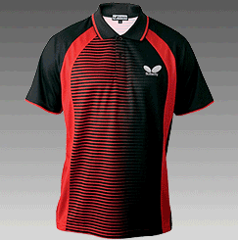 ARCTIC Tracksuit new design 100% Diamond Cool Dry polyester. Straight cut jacket with meshing in various sizes inc lettering. (Normal price (s) £76.99 and £89.99)
XXXS-XS £47.00 (Blue top, Navy Bottom) S-XXXXL £54.99

Basic Butterfly black shorts as last year in black still £13.
New range Nubag Holdall in blue £23.99 (Normal price £39.99)

We still have in stock red Halton TT league polo shirts @ £13.00 while stocks last

Money with order for Halton clothing (cheques payable to Halton TT Club)

Name………………………………..Address………………………………………..

Tel No………………………………………………………

Tick to order and insert size:-
Shirt …….. size Shorts…………… Tracksuit ……. top size… Trouser size……...

Nubag Holdall………….

Amount enclosed…………………………………………

Return to K. Tonge, Halton Regional TT Centre, Halton Stadium, Lowerhouse Lane , Widnes, Cheshire WA8 7DZ

