
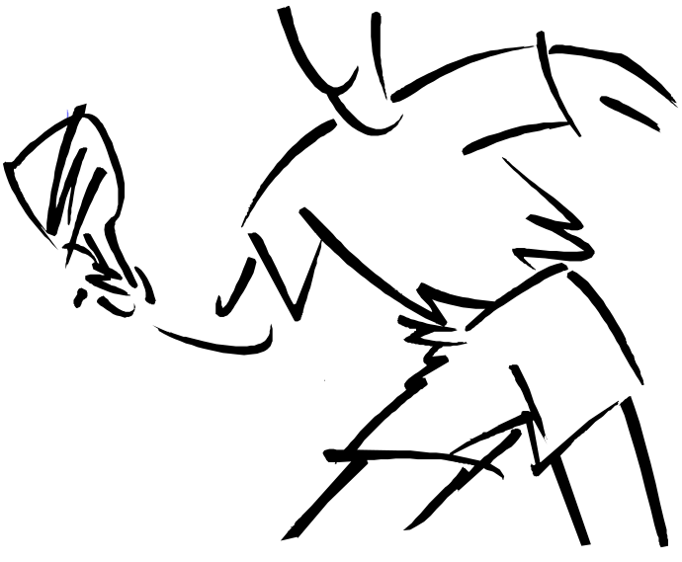


BRITSIH LEAGUE PREMIER DIVISION

HALTON TTC
V
BATTS

To be held at
Halton TT Centre
Saturday 3rd December 2016
from 14:00 pm DOORS OPEN 13:00

Committee:- Karen Tonge MBE, Kenny Bennett
Sam Holland Senior Coach Andrew Rushton
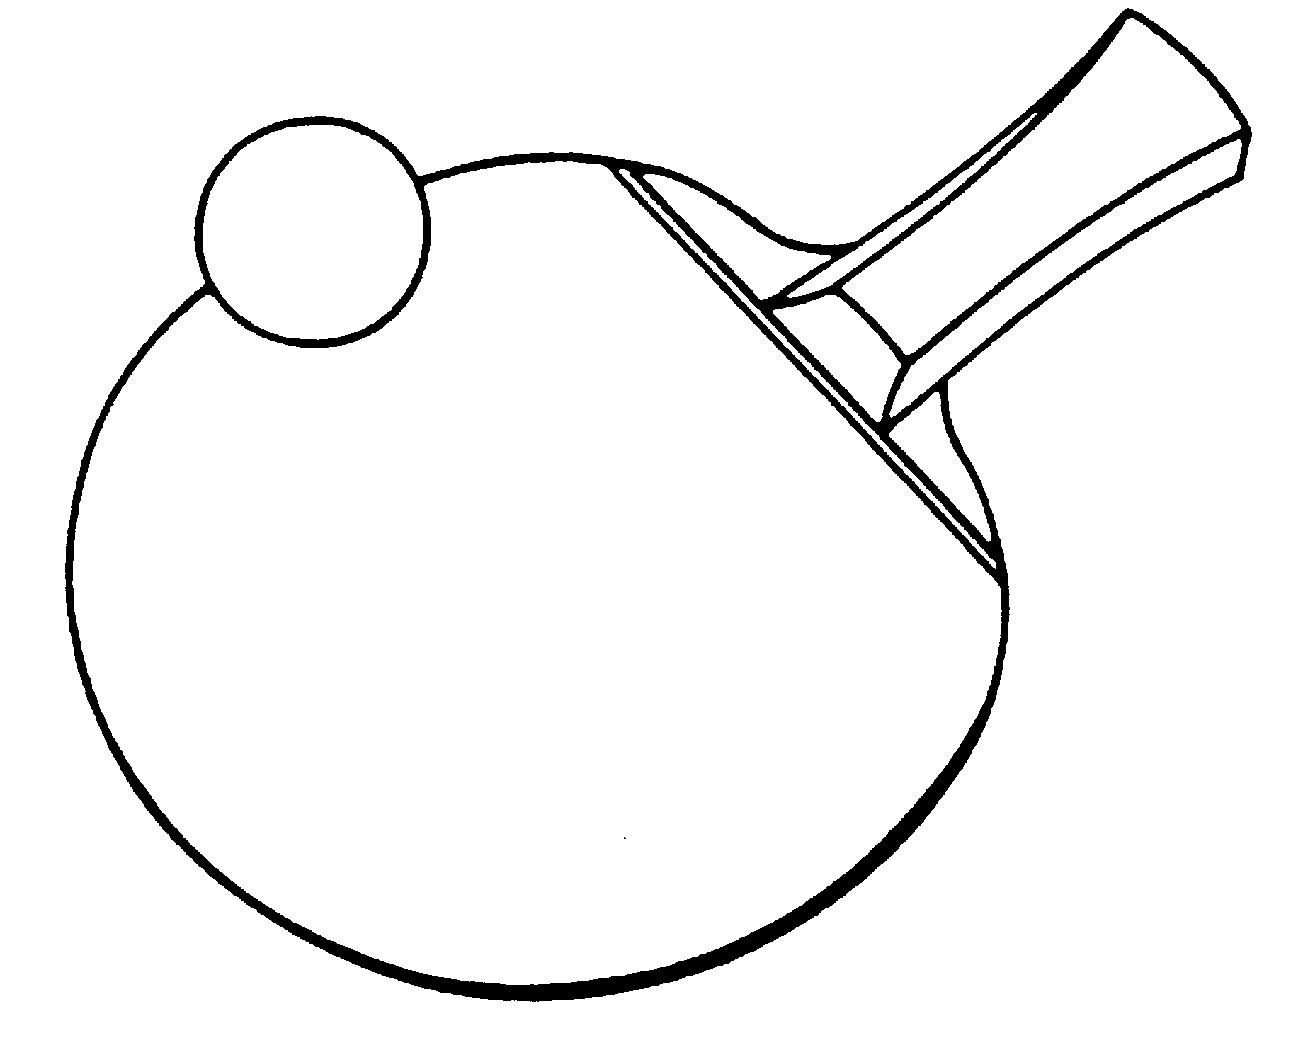

HALTON TABLE TENNIS CLUB
www.haltontabletennis.co.uk.

At last the long awaited first home game of the new format for the Premier British League will see Halton Table Tennis Club take on BATTS of Harlow at our venue, Select Security Stadium in Widnes on Saturday 3rd December 2016 starting at 14:00 pm. Doors will open at 13:00 pm

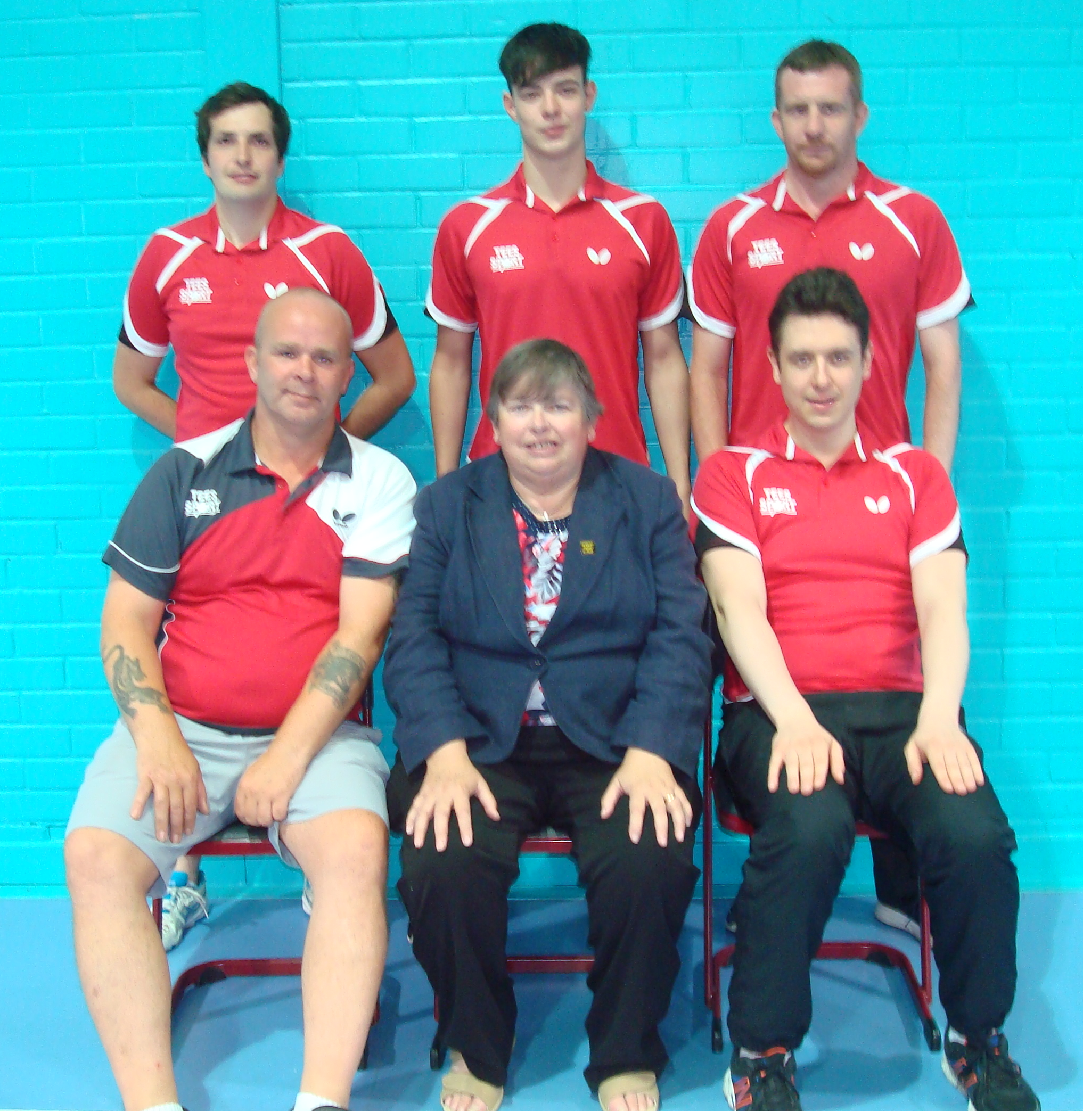
TEAM pictured at Drumchapel for Premier League
Front:- L-R Richard Lightowler, Karen Tonge MBE Chairman, Kenny Lindsay (Scottish International) Back Row:- Aaron Beech, Joe Pilkington (former England Top 6 Junior), Kevin Dolder (beenTop16 Senior)

This is the fifth round of the new British Premier League format after Halton have been by road and rail first to Drumchapel Glasgow TTC, then Cardiff, then to North Aryshire followed by Fusion in London

BRITISH LEAGUE
PREMIER DIVISION PROGRAMME
We welcome BATTS to Halton TT Centre

HALTON |  |  |  |  | BATTS
 | RICHARD LIGHTOWLER |  |  |  |  | ALEX RAMSDEN
 | KEVIN DOLDER |  |  |  |  | STEVE BEERLING
 | JOE PILKINGTON |  |  |  |  | JACK BENNETT
 | TOMASZ RZESZOTKO |  |  |  |  | MATEUSZ ZAGAJEWSKI
 |  | HOME |  | AWAY |  | 1 | 2 | 3 | 4 | 5 | MATCH SCORE
A |  |  | X
B |  |  | W
C |  |  | Z
D |  |  | Y
A |  |  | W
C |  |  | X
B |  |  | Y
D |  |  | Z
REFEREE: - KAREN TONGE MBE, IR
UMPIRES:- TOM PURCELL IU, STAN CLARKE IU,
GRAHAM ROLLINSON CU

